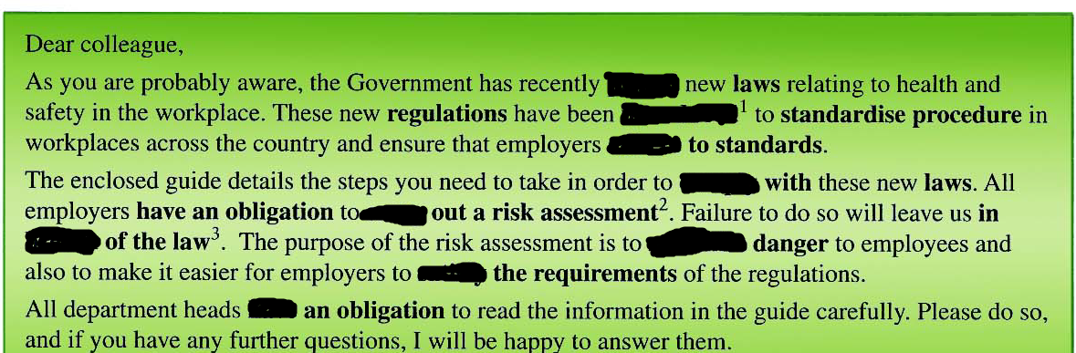

meet, carry , pass, implemented, adhere, comply, breach, mitigate, have,

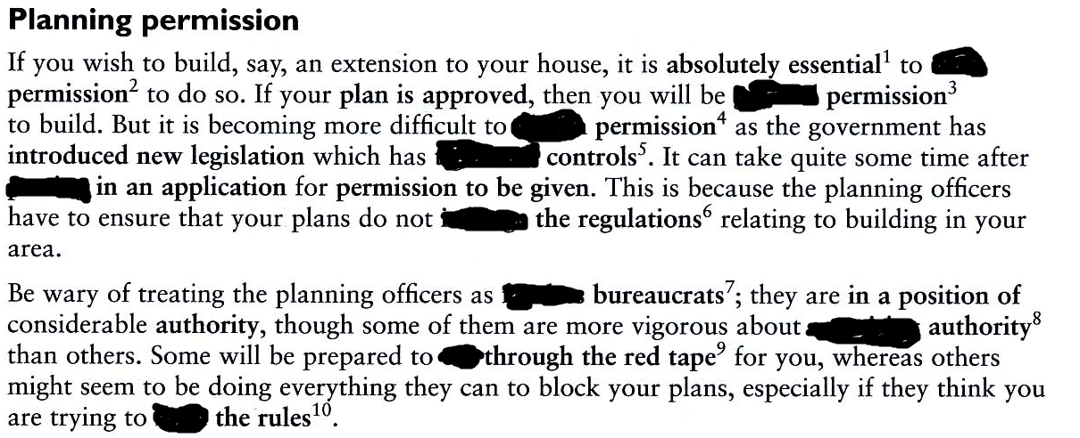

faceless, seek, granted, obtain, tightened, cut, exercise, bend, infringe, putting